Agri Food UK Export Guide
erica0412
Jun 5, 2024
1 min read

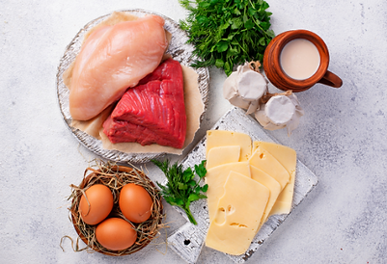
To import live animals or animal products from non-EU countries into Great Britain, you’ll need to: Find the Border Target Operating Model (TOM) risk category for the commodity you’re importing & follow the sanitary and phytosanitary (SPS) rules for that import risk category. The TOM categorises live animals, germinal products, products of animal origin (POAO) and animal by-products (ABPs) as high risk, medium risk or low risk.

TOM Risk Categories in Britain:

Low TOM risk category:

Continue to use IPAFFS to notify authorities before goods arrive in GB, ensuring that the point of entry has a BCP designed to check your commodity. You will not need a health certificate, consignments will not be subject to routine documentary, identity and physical checks unless intelligence indicates a risk.

Medium TOM risk category: Continue to use IPAFFS to notify authorities before the goods arrive in GB. The consignment will continue to need a health certificate issued by the competent authority in the country where the goods originate. Products will continue to enter through a BCP and be subject to documentary, identity and physical import checks.

High TOM risk category: Continue to use IPAFFS to notify authorities before the goods arrive in GB. The consignment will continue to need a health certificate issued by the competent authority in the country where the goods originate. Most consignments in the high TOM risk category are already subject to documentary, identity and physical import checks. These checks will continue.

www.customswise.ie | 01 8665644 | info@customswise.ie

